NEW CLIENT EMDR HANDBOOK AND INFORMATION PACKET

**What is EMDR?**

EMDR is an 8-phase approach to psychotherapy that is internationally recognized as an empirically supported treatment when provided by a clinician who has completed an EMDRIA Approved Basic Training in EMDR.

Scientific research has shown that EMDR is effective for treating a wide variety of issues including, (but not limited to):

* Addiction
* Anger
* Anxiety
* Depression and Bipolar D/O
* Grief and Loss
* Performance Enhancement (athletic/academic/musical/professional)
* Procrastination/Avoidance/Low Motivation
* Relationship enrichment and healing
* Self-esteem
* Stress management
* Trauma-PTSD and Developmental Trauma

**Who endorses EMDR?**

EMDR is currently a top-rated treatment protocol for acute trauma (ex. Car accident and natural disasters) as well as Developmental/Complex Trauma (chronic childhood deprivation and abuse).

The practice guidelines of the **American Psychiatric Association (2004)**, the **American Psychological Association (APA) and the Department of the Veterans Affairs and Defense** (2004) have placed EMDR in the highest category of effectiveness.

**SAMHSA’s national Registry of Evidence-based Programs and Practices** cite EMDR *as the best evidence-based practice for PTSD, anxiety and depression.* In 2013,The **World Health Organization** stated that Trauma-Focused CBT (which I am trained in as well), and EMDR were to be the only psychotherapy models recommended for children and adolescents and adults with PTSD.

The significant benefits of EMDR (when compared to TF-CBT) include:

* With EMDR there are no detailed descriptions of the event needed
* EMDR does not encourage or need extended exposure to the trigger
* With EMDR no homework is involved.

If interested in learning more about EMDR, Specific research citations and information can be found at:

**Emdr.com**

**Emdria.org**

**Traumacenter.org**

**Sonomapti.com/aboutemdr.html**

Article about how EMDR got started:

http://www.emdr.com/history-of-emdr/

**Understanding trauma and how it relates to EMDR:**

When danger is perceived (from the environment or the worries in our minds) the body is wired to respond automatically in these ways:

* The sympathetic nervous system goes into full alert sending stress hormones to the respiratory system, cardiovascular system, and to the muscles in our bodies, preparing us to either “fight or flee.”
* The neo-cortex (thinking part of the brain) shuts down, as does, the Broca’s area for speech. This is because instinct is faster than thought and in a dangerous situation, creating words and taking the time to contemplate our options, is something we are not logistically capable of doing. This also explains why when we feel threatened, it is difficult to both hear information accurately, as well as find the right words to use.
* If we can not fight or flee, all mammals (including humans), prepare to die. Our bodies automatically put us into the “freeze” response. Endorphins (feel-good chemicals) are released from the brain to manage the pain. This results in the mind literally dissociating from the body as well as the actual experience.

*The trauma has literally overwhelmed our coping resources.*

**The trauma does not have to be from physical violence or natural disaster, it can be anything that causes the mind/body/spirit to be overwhelmed and shut down.**

**Where does the trauma go?**

The trauma becomes an experience that gets encoded into our implicit memory. Therefore, instead of having actual words and the ability to accurately recall events, the story is laid down into our memory, in fragments, pieces of images, thoughts, sounds, smells, physical sensations and most important, as highly charged emotions.

This becomes what is also referred to as “the emotional brain”, as the memory begins to actually shape our responses.

**What does this have to do with EMDR?**

The primary purpose of the emotional brain is to keep us safe. Even when it is overactive, (like the “Energizer bunny”), it thinks it is acting to protect us. When the emotional brain is triggered, it is not able to differentiate things happening at the present time, from things that happened when the initial memory was stored. Therefore, our minds become emotionally flooded, creating similar feelings throughout our body, as the ones created during the original memory, making us armed and ready to protect, even when we are not in harmful situations.

Therefore, Trauma is simply memories that are stuck in the emotional brain that have not been updated, while setting up the mind to continually respond to things that are actually not happening. (i.e feeling jumpy at the sound of fireworks after returning from war).

It is clear based on this information that talking ourselves out of feeling a certain way is simply not possible in some situations, especially because our emotional brain, literally takes over our “reasoning” brain. As their needs to be a way to process and heal our memories from the past involving more than our attempt to “rationalize” our way out of it, we as clinicians have been thrilled to have discovered EMDR as a successful way to do so.

EMDR goes deeper than telling us to “think a different way”.

EMDR actually integrates the trauma by encouraging the emotional brain to connect with the reasoning part of the brain through the process of bilateral stimulation. Similar to what happens in REM Sleep, a right to left side eye movement increases the left side of the brain and the ability to reason, awhile decreasing the emotional response we so often get caught off guard by.

Helping to decrease the response and effect that implicit memories previously have had on clients through bilateral stimulation, this new field of psychology has opened up, creating hope for those who were in the past not able to just “get over it”.

**What ages can participate in EMDR?**

EMDR Has been proven to be effective with all ages.

**EMDR Has Helped Kids With**

* Fears, anxieties, compulsive behavior, depression, sleep, and eating disorders
* The effects of big traumas such as ongoing abuse of any kind, war, many surgeries, or a death in the family.
* The effects of little traumas, such as single scary accidents, failures, social problems, animal nips, and nightmares
* Instances where the child feels stuck and wants to change her or his feelings or behavior but can’t do it alone
* Phantom limb pain (when pain is felt to be coming from an amputated body part)
* Emotional effects of all degrees of abuse -- emotional, physical, sexual, and social (abandonment and betrayal)
* Fixes “broken feelings”
* Children who act up or are depressed because they don’t know who loves them and don’t know how to love because they have not bonded to their parents, show huge improvement and participation in life after EMDR sessions
* Children of all ages, who have been traumatized by war, earthquakes, volcanoes, floods, etc., can recover the urge to live after EMDR sessions

(Information provided by Sandra Wilson and Robert Tinker)

What are the Eight States of EMDR?

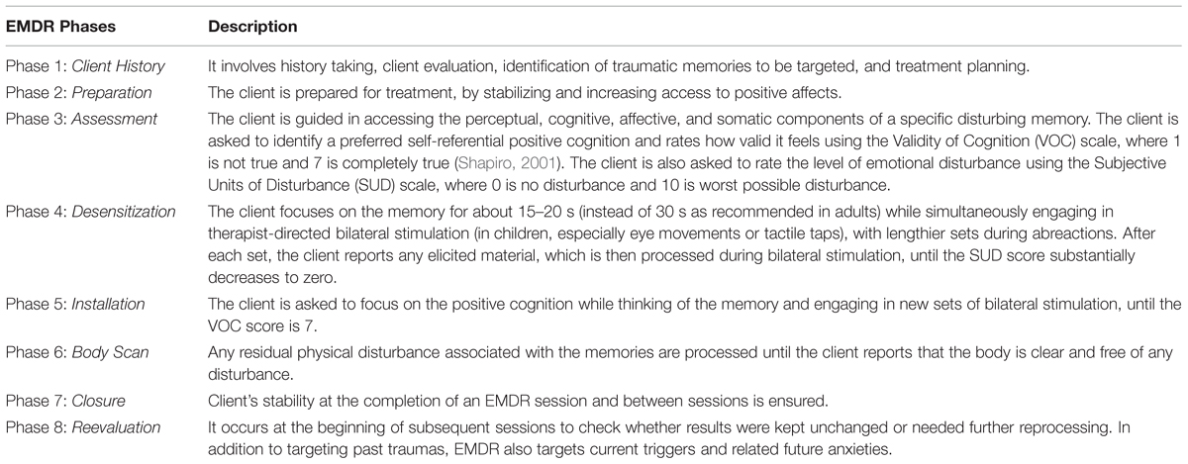

Please note, this is a very simplified description of EMDR and the stages. The flexibility of this model allows for implementing many other treatment techniques along the way. i.e. psychoeducation about boundaries or parenting skills, emotional regulation, etc.

Additional Links via You Tube

Ted Talk:

<https://www.youtube.com/watch?v=lOkSm90f2Do>

Healing Stories: <https://www.youtube.com/watch?v=QiULmoDQe5g&list=PLN9q8RvZD5het8S5N1oUWWtFL1diHzPI9>

https://www.youtube.com/watch?v=_QJbCtr8bvA